Tower Defense Game

Zach Amsler

Nhan Dao

Brandon Weeks

**Use Case Scenarios**

Scenario #1 – Adjust Volume

* Player opens up settings tab/menu
* Player clicks volume on/off
* Volume changes

Pragmatic flow –

* Volume doesn’t change
  + Verify system volume is on

Scenario #2 – Local/All time high-score

* Player opens up high-score menu
* Find player name

Pragmatic flow –

* Cannot connect to high-score
  + Make sure device has internet access
* Doesn’t submit players score
  + Make sure device has internet access

Scenario #3 – Upgrade Tower

* Player selects tower
* Player presses upgrade
* Tower gets upgraded
* Currency decreases

Pragmatic flow –

* Player doesn’t have enough currency
  + Player must play more
* Towers maxed level
  + Player must buy another tower
* Player cannot upgrade tower
  + Player must buy tower first

Scenario #4 – Delete/Sell Tower

* Player selects tower
* Player presses sell/delete
* Player receives X amount of currency
* Tower is deleted from map

Pragmatic flow –

* Player can’t delete/sell tower
  + Player must buy tower first

Scenario #5 – Purchase Tower

* Player selects desired tower
* Player selects location of tower
* Tower gets placed
* Currency gets decreases

Pragmatic flow –

* Player doesn’t have enough currency
  + Player needs to play more
* Player selects wrong location
  + Move tower
* Player selects wrong tower
  + If tower has not yet been placed, select different tower
  + If tower has been placed, sell tower
* Tower cannot be placed at desired location due to place being occupied
  + Select different location

Scenario #6 – Move Tower

* Select tower
* Press move button
* Select desired location
* Tower gets placed at desired location

Pragmatic flow –

* Cannot select tower
  + Buy tower first
* Select wrong location
  + Move tower again
* Select wrong tower
  + Select again
* Tower cannot be moved to desired location due to place being occupied
  + Select different location

Scenario #7 – End Game

* Presses “end game” button or loses
* Go back to the main menu

Pragmatic flow –

* /////////////

Scenario #8 – Start Round/Wave

* Player finishes last round
* Player gets 60 seconds to make adjustments
* Player can start round early via button otherwise round will start automatically
* Enemies begin to spawn

Pragmatic flow –

* Cannot start next round
  + Player must finish current round

Scenario #9 – Change map

* Player starts game from main menu
* Player selects desired map
* Player clicks begin round button

Pragmatic Flow –

* Player chooses wrong map
  + Exit game and start over/select different map

**Use Case Diagram**

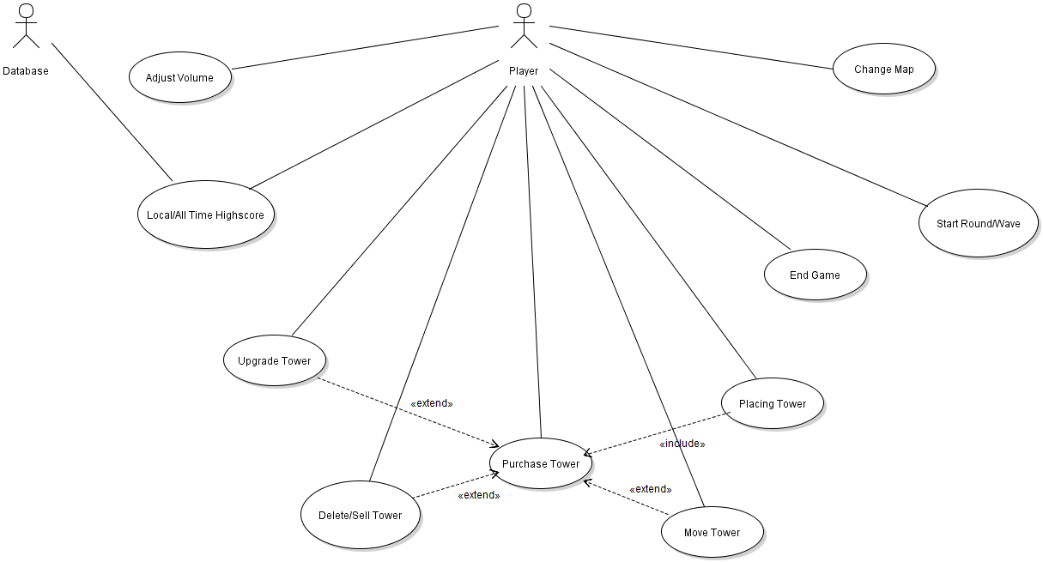

**System Sequence Diagrams**

**Adjust Volume Use Case**

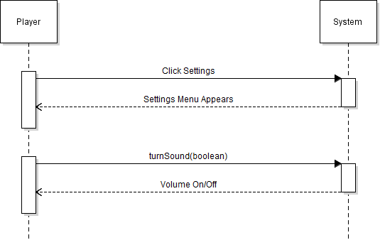

**Start Game Use Case**

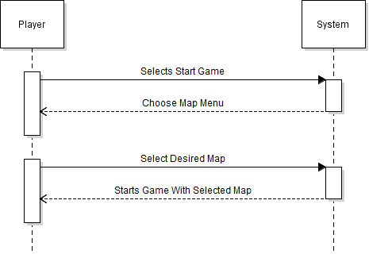

**Exit Game Use Case**

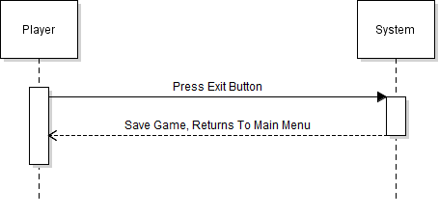

**High Score Use Case**

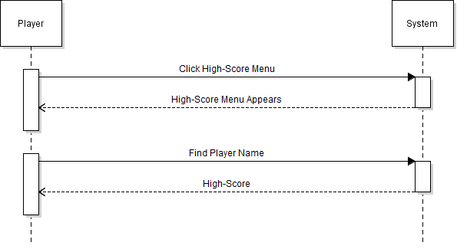

**Select Tower Use Case**

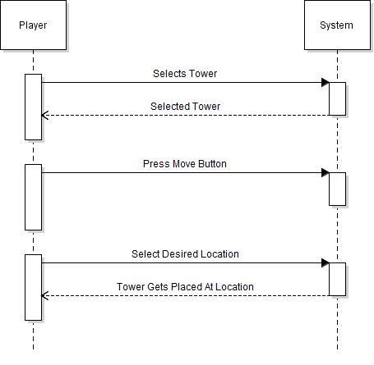

**Move Tower Use Case**

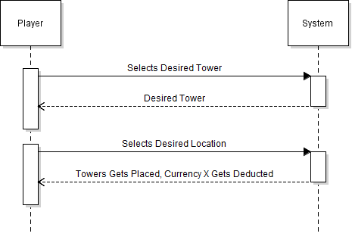

**Sell Tower Use Case**

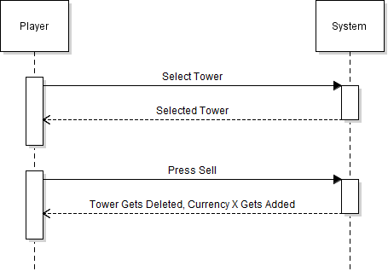

**Start Round Use Case**

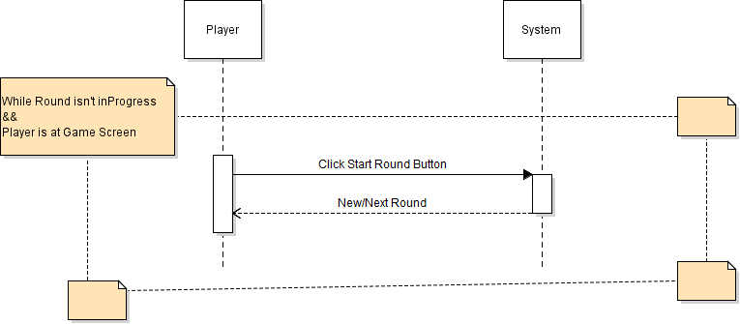

**Upgrade Tower Use Case**

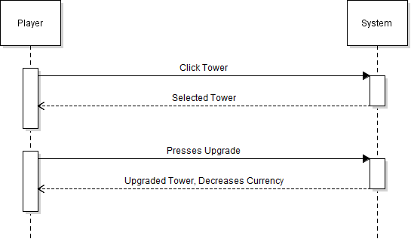

**Domain Diagram**

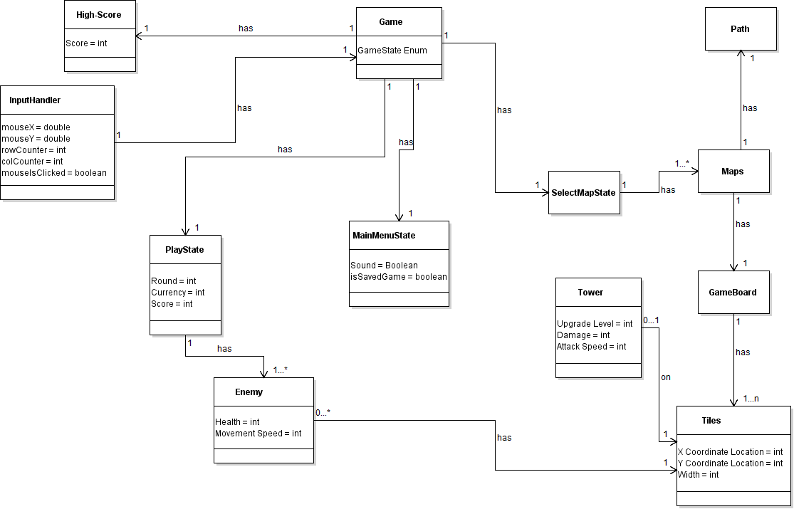

**Class Diagram**

